**Convert Sorted Array to Binary Search Tree:-**

Given an integer array nums where the elements are sorted in **ascending order**, convert *it to a****height-balanced****binary search tree*.

A **height-balanced** binary tree is a binary tree in which the depth of the two subtrees of every node never differs by more than one.

**Example 1:**

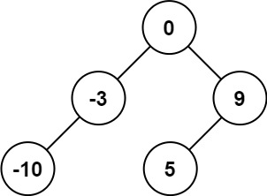

**Input:** nums = [-10,-3,0,5,9]

**Output:** [0,-3,9,-10,null,5]

**Explanation:** [0,-10,5,null,-3,null,9] is also accepted:

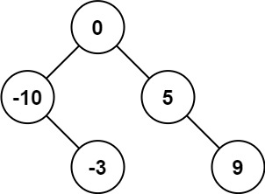

**Example 2:**

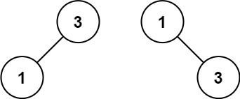

**Input:** nums = [1,3]

**Output:** [3,1]

**Explanation:** [1,3] and [3,1] are both a height-balanced BSTs.

**Constraints:**

* 1 <= nums.length <= 104
* -104 <= nums[i] <= 104
* nums is sorted in a **strictly increasing** order.

s